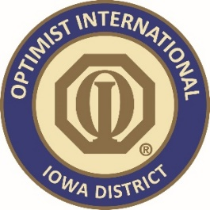
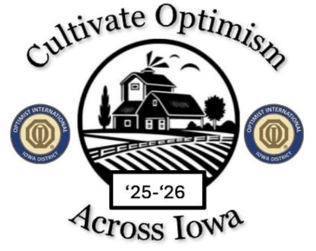
2025-2026 Iowa District Optimist Convention August 28 - 30, 2026
Grand Harbor Resort 350 Bell Street Dubuque, IA 52001 563-690-4000 Rooms $159 (plus taxes/fees), Room Block expires July 28, 2026 Price includes full breakfast and access to the water park.

Price Total
Hold my spot! (feel free to make quarterly payments) $25 minimum _________ Amount goes toward total registration Full Registration (if registered by July 28, 2026) Includes: $135 __________
General Sessions, Training, Model Club Luncheon, Friday Fun Night, Governor's Banquet and All-Optimist Breakfast AFTER JULY 28 - PRICE IS $175
Prices below are single event registration amounts
Friday, August 28, 2026 Friday Fun Night (included in full registration) $30 __________ AFTER JULY 28 - PRICE IS $50
Saturday, August 29, 2026 Model Club Luncheon (included in full registration) $45 __________ AFTER JULY 28 - PRICE IS $65
Governor's Banquet & Entertainment (included in full registration) $55 __________ AFTER JULY 28 - PRICE IS $75
Sunday, August 30, 2026 All Optimist Breakfast (included in full registration) $35 _________ AFTER JULY 28 - PRICE IS $45
Subtotal: _________
Amount Enclosed _________
Make check payable to: Iowa District Optimist Convention 2026 Attn: Barb Perleth 2455 Rolling Creek Lane, Dubuque, IA 52003
NOTE: One form per person please
Name: _______________________________________________________________________________ Club Name, Number, Club Position: ____________________________________________________________ Address: ____________________________________________________________________ City: ______________________________________ State: ______ Zip: ____________ Phone: ____________________________ Special Food Needs: ___________________ E-Mail: _____________________________________________ Are you a First-Timer to a district convention? Yes No

